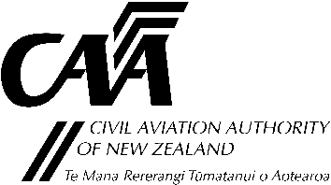
Report an Occurrence – Regulated Air Cargo Agents
The Civil Aviation Authority encourages reporting of all security-related incidents or concerns, even when these may not reach the formal requirements for reporting under Civil Aviation Rule Part 12. Details of security occurrences help the CAA identify threats or risks to the aviation sector.
We invite you to use this form to voluntarily report security incidents or concerns to the Security Regulation Unit which do not require formal reporting. Incidents or concerns include suspicious interactions, observations of security concern, or anything else that makes you feel uncomfortable.
Once received, the form will be assessed and assigned to a member of the Security Regulation Unit who will contact you.
Complete all sections as fully as you can, send additional pages if required.
Name
Position
Company
CAA participant number (if known) |  |  |  |  | Date
Tel |  |  | Email
Postal address
Details of Occurrence
Date |  | Time
Location
DESCRIPTION
Please describe the occurrence. Include details of what happened, where it happened, when, and who was involved. If you know how or why, please include that as well.

Please email or post this form to:
Email security.regulation@caa.govt.nz Post Security Regulation Unit
Civil Aviation Authority
Further enquiries +64 4 830 0513 PO Box 3555
Wellington 6140
CA005R
Rev 1: Jan 2023

